**GAME 3011 - Assignment 3 GDD**

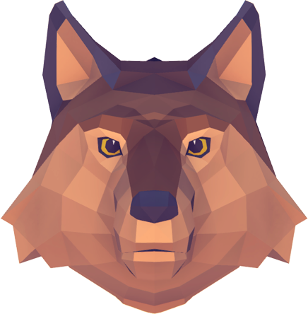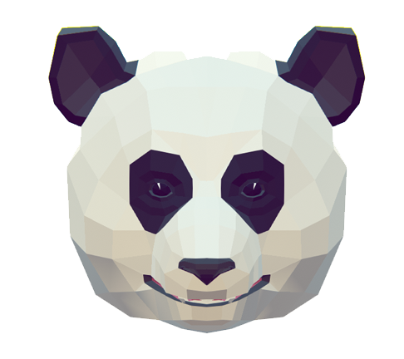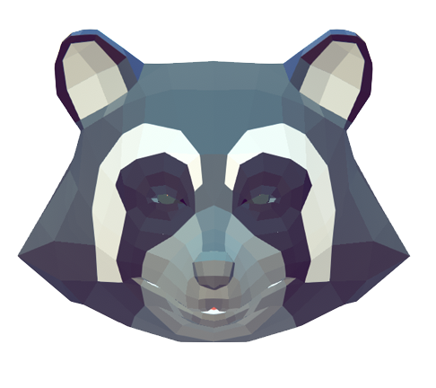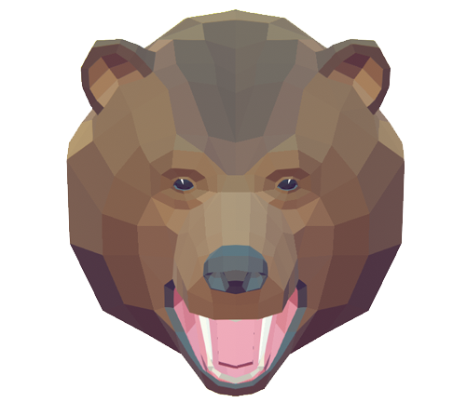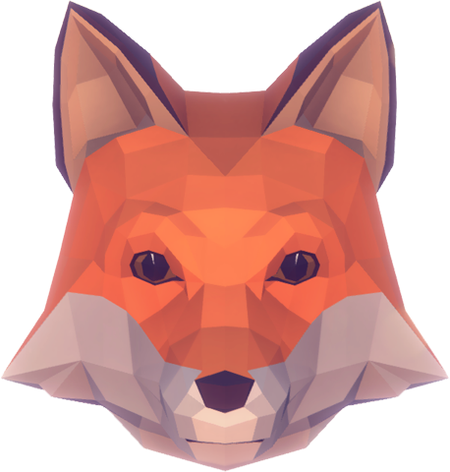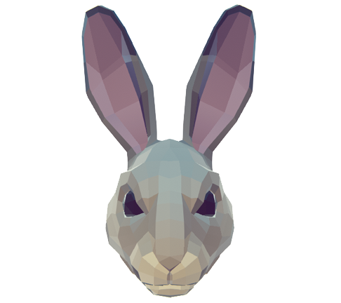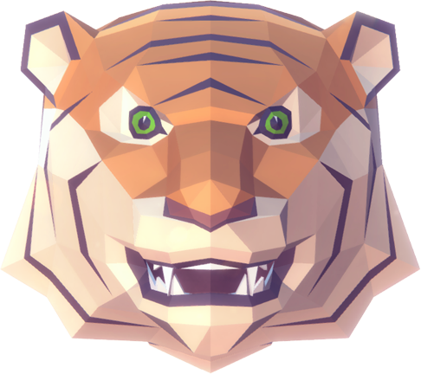

**Theme of the Game System**

This is a match 3 Game that has a 5 by 5 grid with 7 different types of tiles. The tiles are represented by Animal face icons. The animals that are represented are: Bear, Fox, Rabbit, Panda, Racoon, Tiger, and Wolf. The game is played in a background with a few trees in a Grassland.

**Overall Game System**

The goal of the game is to reach the total points you are required to pass the level, by making 3 matches of the same animal. But you are only given 30 seconds to gain all the points you need to have to pass. Each animal has a point value. Here are the values of each animals:

* Fox: 5 points
* Grizzly Bear: 10 points
* Panda: 5 points
* Tiger: 10 points
* Rabbit: 5 points
* Racoon: 5 points
* Wolf: 10 points

When you make the match, it will multiply on the number of animals in a match e.g., if you make a match with three Pandas will earn 15 points (5 x 3 = 15), and a match with three Wolves will earn 30 points (10 x 3 = 30). Making a match of more than 3 like a match 4 or match 5 will give you bonus points, which should satisfy the player, since you get closer to the required goal point.

After you make a match the tile will automatically randomize which animal icon it will represent next, there is no dropdown. And sometimes there will be an automatic match, which is very helpful to reaching the goal point.

To swap tiles you just click on the two neighboring tiles you want to swap, there is no dragging, and you can’t swap diagonally! If you try to swap a tile that is not a neighbor horizontal or vertically, it will just wait until you click on a neighboring tile that is horizontal or vertical from the first tile. For the tile animation to pop and swap I imported the DOTween to the Unity project, which is a Tween Engine.

To open the minigame panel, you must click the ‘E’ keyboard button and play the Match-3 minigame. When the Match-3 Game Panel pops up, music plays until the game is finished. After you have completed the game, there will be an exit button that closes the minigame pop-up panel.

**Level of Difficulty**

The level of difficulty is represented by the goal points, which gives the player a challenge on how many points they need to gain in 30 seconds to win. Here are the different goal points for each difficulty:

* Easy - 250 points
* Medium - 350 points
* Hard - 450 points

For Easy, it is quite winnable to gain 250 points in 30 seconds, as long as you seek for animals that give you higher points (Bear, Tiger, Wolf), and make multi matches of 4 or 5.

For Medium, you also have to seek for animals that give you higher points and multi matches, but you somewhat need to rely or hope for automatic matches.

And for Hard, that’s when you are really relying on automatic matches, and also trying to quickly find matches to rush to get to 450 points.

**Interesting Features**

The Interesting Feature of the game is that you don't only have to match animals in a straight line, you can match animals in an L shape, T shape, S shape, or 2 by 2 square shape. That is because when the tiles connect, it checks for each neighbor to see which ones connect to each other horizontally or vertically.